**Business Requirement Document**

**Of**

**AI-Powered Job Recommendation System for Freshers**

**1.Document Information Table:**

|  |  |
| --- | --- |
| **Item** | **Description** |
| **Document Owner** | Selvasekar M |
| **Project Name** | AI-Powered Job Recommendation System for Freshers |
| **Document Type** | Business Requirement Document (BRD) |
| **Prepared By** | Selvasekar M |
| **Created On** | 13 June 2025 |
| **Current Version** | v1.3.2 |
| **Status** | Draft |

**1.1 Version history:**

|  |  |  |  |  |
| --- | --- | --- | --- | --- |
| **Version** | **Date** | **Description of Change** | **Author** | **Status** |
| v1.0 | 13-Jun-2025 | Initial draft created | Selva M. | Draft |
| V1.1 | 14-Jun-2025 | Stakeholder communication added | Selva.M | Draft |
| V1.2 | 15-Jun-2025 | Functional requirement updated | Selva.M | Draft |
| V1.3 | 21-Jun-2025 | Non-functional requirement updated | Selva.M | Draft |
| V1.3.1 | 23-Jun-2025 | Use case summaries added | Selva.M | Draft |
| V1.3.2 | 30-Jun-2025 | Use case summaries updated | Selva.M | Completed |

**2. Project Overview:**

**2.1 Background:**

In today’s job market, fresh graduates often struggle to find relevant job opportunities that match their skills and qualifications. Most job portals are designed for experienced professionals and do not cater specifically to entry-level job seekers. This results in a disconnect between freshers and employers looking for junior talent.

The idea behind this project is to build a smarter platform that connects freshers and recruiters in a more meaningful, AI-powered way.

**2.2 Project Vision:**

The vision of this project is to build an intelligent, easy-to-use job recommendation platform that helps freshers discover jobs tailored to their profiles, while also providing employers with a dashboard to find the most relevant candidates with minimal effort.

**2.3 Product Description:**

The AI-Powered Job Recommendation System for Freshers is a web-based application designed with two main user types: job seekers and employers.

Freshers will be able to register, upload their profiles, and receive personalized job recommendations based on their skills and academic background. Employers will have their own dashboard where they can post jobs, view applicants, and receive AI-matched candidate suggestions.

The system will also include application tracking, resume uploads, and a clean user interface optimized for ease of use.

**3. Business Objective:**

**3.1 Business Problems:**

1. Fresh graduates find it difficult to discover job opportunities that are relevant to their skills, qualifications, and interests.
2. Existing job platforms are not tailored for entry-level or fresher job seekers.
3. Employers struggle to filter and find suitable candidates for fresher roles.
4. There is no intelligent, AI-based system that matches freshers to jobs in a personalized way.
5. Job search platforms often lack clear tracking features for both applicants and recruiters.

**3.2 Business Objectives:**

1. To provide fresh graduates with AI-based, personalized job recommendations that match their profiles.
2. To allow employers to post jobs, manage listings, and discover matched candidates via a dedicated dashboard.
3. To reduce the time freshers spend searching for jobs by guiding them toward the most relevant opportunities.
4. To simplify the job application and tracking process for both job seekers and employers.
5. To build a clean, easy-to-use, mobile-friendly web platform that benefits both users and recruiters.

**4. Scope of the Project:**

**4.1 In-Scope:**

* User registration and login system for job seekers and employers
* Resume/profile creation by job seekers
* AI-based job recommendation engine for freshers
* Job search with filters (e.g., category, location, job type)
* Employer dashboard to:
  + Post new job openings
  + View and manage candidates
  + Receive AI-matched candidate suggestions
* Application tracking system for job seekers
* Mobile-friendly web UI for all user roles
* Basic security measures (authentication, password protection)
* User feedback/contact form

**4.2 Out-of-Scope:**

* Integration with third-party platforms like LinkedIn, Google Jobs, or Indeed
* In-app messaging or real-time chat between employers and job seekers
* Video interviews or interview scheduling features
* Resume-building tools or templates
* Subscription models or payment gateways
* AI-powered resume scoring or parsing
* Mobile app (only responsive web app will be built)
* Detailed analytics/reporting dashboard for admin or employers

**5.Stakeholder Communication:**

|  |  |  |  |
| --- | --- | --- | --- |
| **Stakeholder Name** | **Role / Title** | **Department / Type** | **Responsibilities** |
| Selvasekar M | Business Analyst | Project Initiator | Requirement gathering, documentation, coordination |
| Ankit (Persona) | Job Seeker (Fresh Graduate) | End User – Job Seeker | Uses the system to get job recommendations and apply to jobs |
| Priya (Persona) | HR Recruiter | End User – Employer | Posts jobs, views applicants, shortlists candidates |
| Ravi (Persona) | Non-Tech Fresher | End User – Job Seeker | Needs simplified UI and matched jobs based on interests |
| Product Owner (Simulated) | Product Owner | Business Stakeholder | Provides vision, business priorities, and approves scope |
| Developer (Simulated) | Full Stack Developer | Technical Team | Builds and implements platform features |
| QA Engineer (Simulated) | Quality Analyst | Testing Team | Validates functional & non-functional requirements |

**6.Assumptions and Constraints:**

**6.1 Assumptions:**

* Users (both job seekers and employers) will have access to a stable internet connection and a modern browser.
* Employers will post only legitimate and verified job openings.
* Job seekers will provide accurate personal, academic, and professional details.
* The AI recommendation system will use predefined logic/rules (not machine learning in MVP).
* The platform will be hosted as a responsive web application, not a mobile app.

**6.2 Constraints:**

* This project is developed as a self-initiated BA portfolio project — no real company is involved
* All tools used must be free to use (e.g., Trello, Figma, Confluence Free, etc.)
* Development and testing are simulated — no actual deployment will be done
* The UI design will be created using Figma, but no interactive front-end will be built

**7.Business Requirements:**

|  |  |
| --- | --- |
| **ID** | **Business Requirement** |
| BR-01 | The system must allow fresh graduates to create an account and log in securely. |
| BR-02 | The system must allow job seekers to create and update a professional profile. |
| BR-03 | The system must provide personalized job recommendations based on user profiles. |
| BR-04 | Job seekers must be able to search and apply for jobs using relevant filters. |
| BR-05 | The system must allow employers to register and access their own dashboard. |
| BR-06 | Employers must be able to post new job openings with full job descriptions. |
| BR-07 | Employers should be able to view applicants for each job posting. |
| BR-08 | Employers must receive a list of AI-suggested candidates based on job requirements. |
| BR-09 | Job seekers must be able to track the status of their job applications. |
| BR-10 | The platform must provide a user-friendly and mobile-responsive interface. |
| BR-11 | The system must support basic admin controls for platform oversight. |
| BR-12 | The system should allow users to submit feedback or contact support. |

**8.Functional Requirements:**

|  |  |
| --- | --- |
| **ID** | **Functional Requirement** |
| FR-01 | The system shall allow users (job seekers and employers) to register and log in securely. |
| FR-02 | Job seekers shall be able to create, edit, and view their profile including education, skills, and resume. |
| FR-03 | The system shall use pre-defined rules to suggest jobs to users based on their profiles. |
| FR-04 | Users shall be able to search for jobs using filters like job role, location, and category. |
| FR-05 | Job seekers shall be able to apply for jobs directly through the platform. |
| FR-06 | The system shall allow employers to create and manage job listings with full details. |
| FR-07 | Employers shall be able to view applicants for each job and access their profile/resume. |
| FR-08 | The system shall match candidates to job postings using AI logic and display suggestions to employers. |
| FR-09 | The system shall maintain a basic application tracking system for both employers and job seekers. |
| FR-10 | The platform shall provide a dashboard interface for employers to manage job listings and candidates. |
| FR-11 | The system shall include a simple admin module to review and moderate reported content or users. |
| FR-12 | The interface shall be responsive and mobile-friendly for all user roles. |
| FR-13 | The system shall include a contact/feedback form for user support inquiries. |

**9.Non-Functional Requirements:**

|  |  |
| --- | --- |
| **ID** | **Non-Functional Requirement** |
| NFR-01 | The system shall load all standard pages within 3 seconds on a stable internet connection. |
| NFR-02 | The platform shall be available to users 24/7 with a minimum uptime of 99%. |
| NFR-03 | All passwords and sensitive user data shall be encrypted and stored securely. |
| NFR-04 | The system shall support up to 1,000 concurrent users without performance degradation. |
| NFR-05 | The platform shall be mobile-responsive and function correctly on all modern devices. |
| NFR-06 | The UI shall be designed to be clean, intuitive, and accessible for non-technical users. |
| NFR-07 | The platform shall follow basic data privacy best practices and not share user data externally. |
| NFR-08 | The system shall allow easy updates or feature enhancements without affecting core functionality. |
| NFR-09 | Any error or failure shall be captured through basic logging for debugging and future improvements. |

**10.User Journey Overview:**

**10.1. Job Seeker Journey – Ankit (Fresher)**

Ankit, a recent computer science graduate, visits the job recommendation platform for the first time. He quickly signs up using his email, then sets up his profile by entering his academic background, skills, and uploading his resume.

Once his profile is complete, the system immediately shows him a list of job openings tailored to his background. Ankit browses the recommendations and applies to a few jobs with a single click.

Later, he logs back in to track the status of his applications and receives notifications when a recruiter shortlists his profile. He also receives new job recommendations every week based on updates to his profile.

**10.2. Employer Journey – Priya (HR Recruiter)**

Priya is an HR executive at a startup looking to hire entry-level software developers. She logs in to her employer dashboard and posts a new job opening with all the required details.

Once the job is posted, she receives a list of AI-matched candidates from the platform. She reviews the profiles, downloads a few resumes, and shortlists some candidates.

Through her dashboard, she can see which jobs are getting attention, track applicants, and mark candidates for follow-up. The platform helps her save time by automatically bringing the best-fit candidates right to her.

**11.Use Case Summaries:**

|  |  |  |  |
| --- | --- | --- | --- |
| **Use Case ID** | **Use Case Title** | **Participant** | **Description** |
| UC-01 | Register as Job Seeker | Job Seeker | Allows freshers to sign up and create an account to access the platform. |
| UC-02 | Create & Edit Profile | Job Seeker | Enables users to enter personal, academic, and skill details along with uploading resumes. |
| UC-03 | Apply for a Job | Job Seeker | Let’s job seeker’s view recommended or searched jobs and apply in one click. |
| UC-04 | Register as Employer | Employer | Allows company recruiters to register and access the employer dashboard. |
| UC-05 | Post a Job Opening | Employer | Enables employers to create and publish job listings to attract candidates. |
| UC-06 | View & Manage Applicants | Employer | Let’s employers see who applied for their jobs, view profiles, and shortlist candidates. |

**12. Process Flows:**

**Fig No: 1 – Registration Flow**

**Fig No: 2 – Create & edit profile**

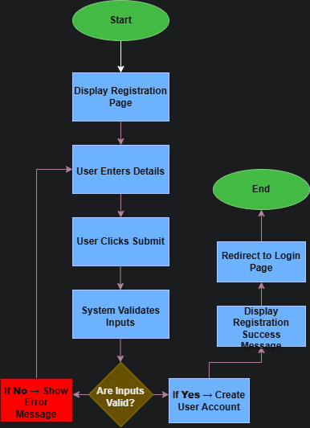

**Fig No: 3 – Register as Job seeker**

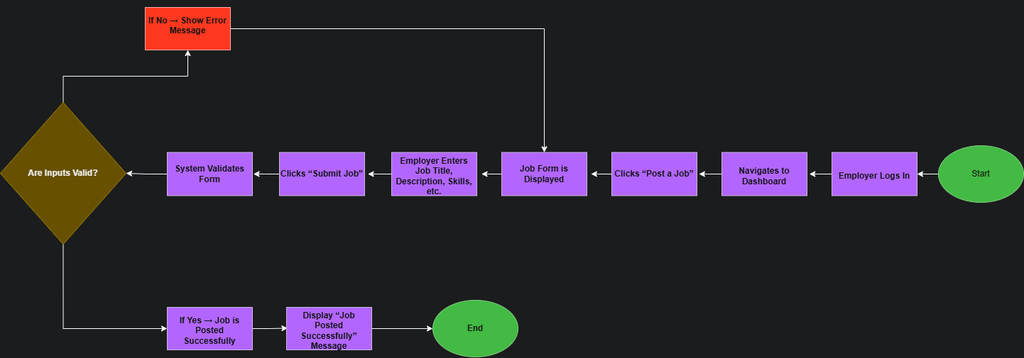

**Fig No: 4 – Post a job opening**

**Fig No: 5 – Applying for a job**

**Fig No: 6- View & manage application**

**13. Wireframes:**

**Fig No: 7 – Registration**

**Fig No : 8 - Job seeker dashboard**

**Fig No: 9 – Job details page**

**Fig No: 10 – Employers Dashboard**

**13. Glossary:**

|  |  |
| --- | --- |
| **Term** | **Definition** |
| **AI** | Artificial Intelligence – technology used to analyse and recommend jobs. |
| **Job Seeker** | A user who is searching for a job on the platform. |
| **Employer** | A company or individual posting job opportunities. |
| **Dashboard** | The main screen showing an overview of user-specific information. |
| **Application Status** | The progress stage of a job application (e.g., Pending, Viewed, Rejected). |
| **Recommendation Engine** | A system that suggests jobs to users based on their profile and behaviour. |
| **UAT** | User Acceptance Testing – done by end-users to validate system behaviour. |
| **BRD** | Business Requirements Document – defines the business needs and scope. |
| **RTM** | Requirement Traceability Matrix – tracks each requirement to delivery. |
| **Wireframe** | A visual representation of a screen layout before development. |